Please note – This application must be completed and returned to Ms. Stinson in Guidance by October 2nd 2020.

Loran Scholarship Application 2020

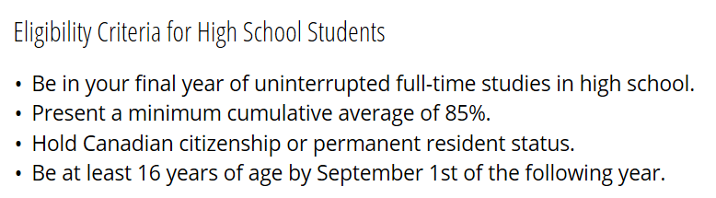

As you complete this application form please remember that the Loran Foundation is looking for students who demonstrate character, service and leadership in their actions so please ensure you highlight these areas in your answers.

Name: _____________________________ Homeroom:_________________________

Briefly explain your post-secondary academic and/or career plans: ________________________________________________________________________________________________________________________________________________________________________________________________________________________________________________________________________

Post-secondary institutions you are considering, in order of preference:
Institution | Program Name

Part 1 – Activity Record
1. EMPLOYMENT / ENTREPRENEURIAL
Please list your current and previous paid employment (jobs where you earned a wage)

Employer | Position | Start Date  (YYYY/MM) | End Date  (YYYY/MM) | Avg Hrs/week

2. ACTIVITIES
Please list all activities in which you have participated since September 2017, including those in your final academic year. Where applicable, please indicate your role in each year you participated. The academic year runs from September to August.
School and Community Service |  | Artistic/Musical
Activity/your role | Grades/years you participated | Activity/your role | Grades/years you participated
1. |  | 1.
2. |  | 2.
3. |  | 3.
4. |  | 4.
Competitions/Conferences/Special Programs |  | Athletics
Activity | Grades/years you participated | Activity | Grades/years you participated
1. |  | 1.
2. |  | 2.
3. |  | 3.
4. |  | 4.
3. Hobbies 4. Awards/Distinctions

Please list, in order of importance to you, up to 4 school or community activities in which you have invested significant energy in the last three years, and state how you contributed. Be sure to include the approximate number of hours per week.
1.Activity/Role: |  |  | Hours Per Week:
Start date (YYYY/MM) | End date (YYYY/MM) | Describe your contribution:
2.Activity/Role: |  |  | Hours Per Week:
Start date (YYYY/MM) | End date (YYYY/MM) | Describe your contribution:
3.Activity/Role: |  |  | Hours Per Week:
Start date (YYYY/MM) | End date (YYYY/MM) | Describe your contribution:
4.Activity/Role: |  |  | Hours Per Week:
Start date (YYYY/MM) | End date (YYYY/MM) | Describe your contribution:

Part 2 – Essay Questions (Please type your answers and attach them to your application form)
i) Describe your most significant volunteer contribution. Why did you do it? How did it impact others? (Max 300 words)

ii) Describe a time you challenged yourself by going outside your comfort zone. What was the risk? Was it worth it? (Max 300 words)

Part 3 – Leadership roles
Please list up to three significant leadership roles where you were responsible for organizing a group of people to achieve a common goal or task.

ii)

iii)
a) Choose the leadership role above that was the most meaningful for you. How did you establish a goal? Describe the steps you took to reach the goal. What were the results? What challenges did you face within your group, and how did you resolve them? Overall, what did you learn about leading others through this experience? (Max 350 words)

b) Describe a time when you took the initiative to address an unmet need at school or in the community. What was the need? What did you do? What was the impact? (Max 200 words)

Please provide the names of two teachers who can attest to your role as a Leader in the school or the community at large, your Entrepreneurial spirit and Volunteer work in the school and or the community. ________________________ _________________________

